Stay Local, Go Far Social Media Messaging

Message | Copy | Artwork | Link
To show your support | We're backing the #StayLocalGoFar campaign to highlight the fantastic career opportunities available in the Tees Valley and encourage our talented local young people to consider future careers here📍🗺️  Find out more👇  www.teesvalleycareers.com/students/staylocal/ | 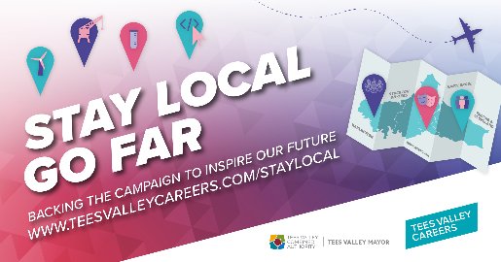 | To our campaign web page: www.teesvalleycareers.com/staylocal
To show your support | There are more career opportunities than ever before right here in the Tees Valley🙌  It's time to dream BIG!  We're joining the #StayLocalGoFar campaign to help our talented local young people find their future in the Tees Valley🗺️  Find out more👇  www.teesvalleycareers.com/students/staylocal/ |  | To our campaign web page: www.teesvalleycareers.com/staylocal or to your Stay Local Go Far – Business Profile blog
To share your business profile blog | Want to know what type of career opportunities you could find at [insert business name]?  Read our #StayLocalGoFar blog to find out more and get our top tips for breaking into our industry🙌  Read more👇  www.teesvalleycareers.com/students/staylocal/ |  | Link to your Stay Local Go Far – Business Profile blog on www.teesvalleycareers.com

#StayLocalGoFar
@TeesValleyCA
@TeesValleyCareersUK

